**Activity Chart**

**Time Line (Start to Finish)**

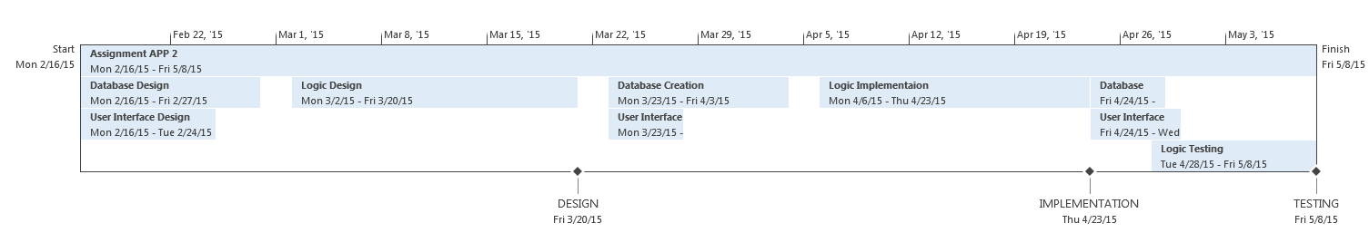

**Bar Chart (Displays the critical path tasks in orange and the tasks with slack time in purple)**

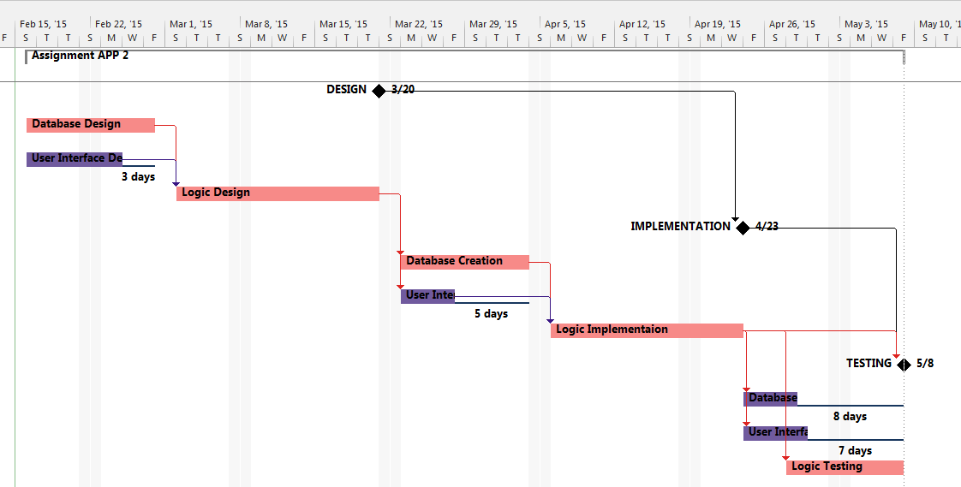

**Gantt Chart with Milestones in BOLD**

